RF synthesizer default value: 4596301446 Hz

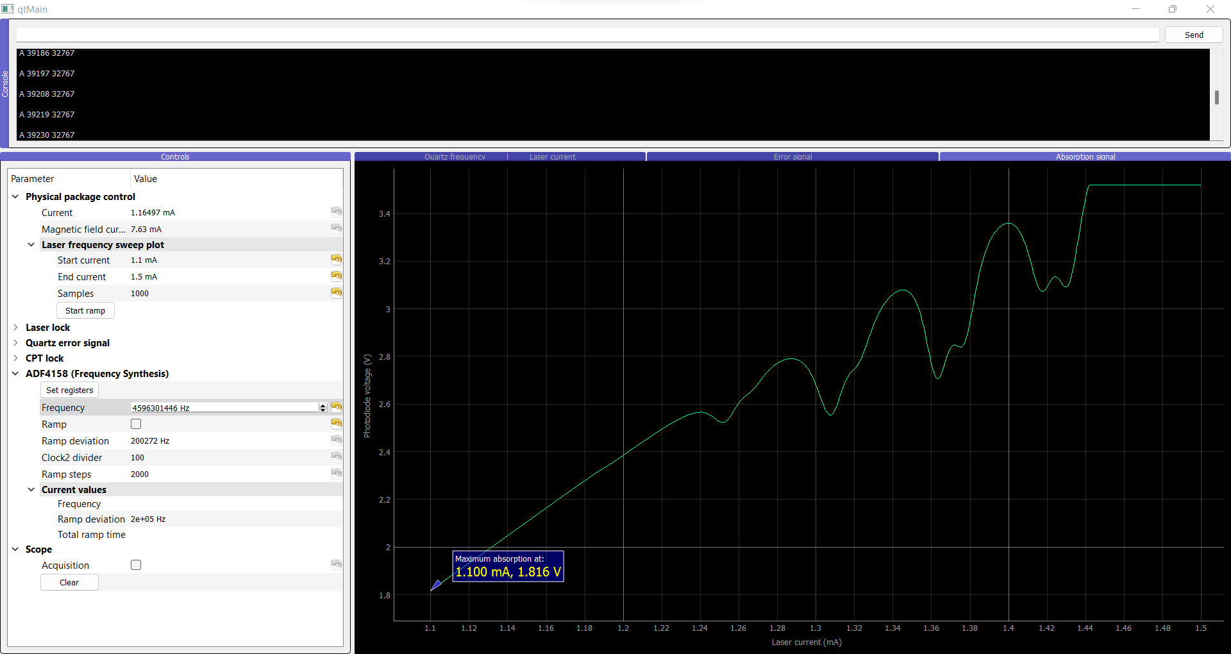

Absorption at: 2.708 V

Modification: 4566301446 Hz

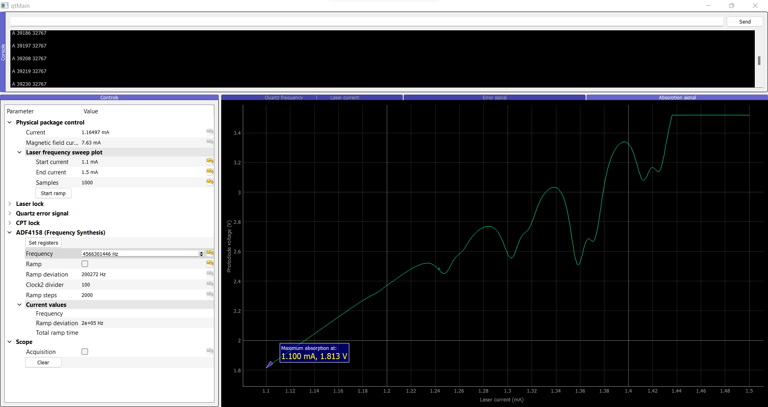

Absorption at: 2.51 V

Modification: 4556301446 Hz

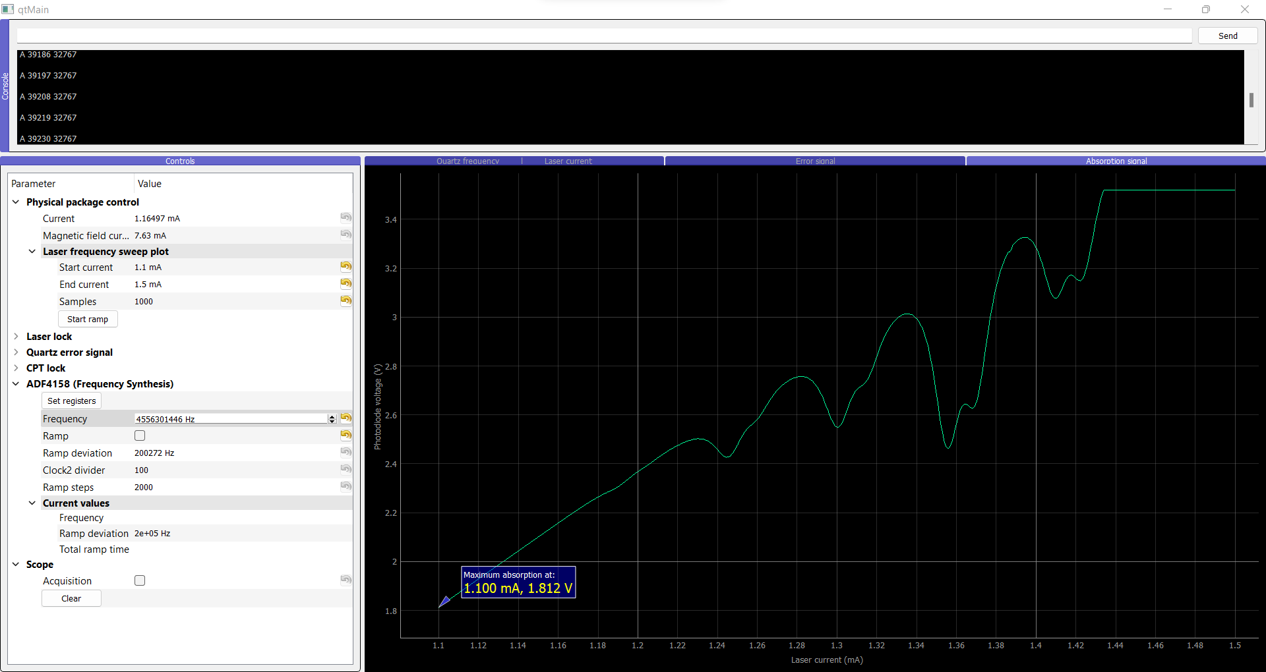

Absorption at: 2.46 V

At 4596376300 “0” is at 23000

Conclusion: Changing the PLL frequency seems to increase the absorption but it is no longer possible to find a CPT signal when doing a quartz VCO scan. This was not a good solution and was not implemented in the final code.